J2ME Sample Game 2 – Game Action

Screenshot

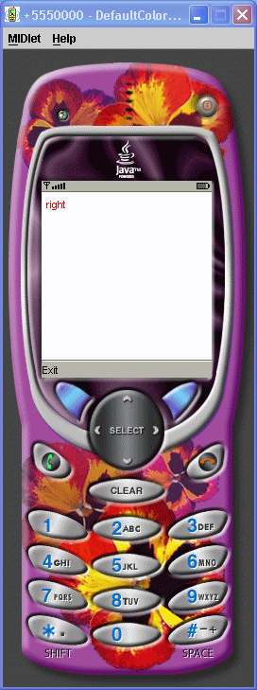

Source Code

/*
J2ME: The Complete Reference
James Keogh
Publisher: McGraw-Hill
ISBN 0072227109
*/
//jad file (please verify the jar size)
/*
MIDlet-Name: GameActionExample
MIDlet-Version: 1.0
MIDlet-Vendor: MyCompany
MIDlet-Jar-URL: GameActionExample.jar
MIDlet-1: GameActionExample, , GameActionExample
MicroEdition-Configuration: CLDC-1.0
MicroEdition-Profile: MIDP-1.0
MIDlet-JAR-SIZE: 100
*/
import javax.microedition.midlet.*;
import javax.microedition.lcdui.*;
public class GameActionExample extends MIDlet
{
private Display display;
private MyCanvas canvas;
public GameActionExample()
{
display = Display.getDisplay(this);
canvas = new MyCanvas (this);
}
protected void startApp()
{
display.setCurrent(canvas);
}
protected void pauseApp()
{
}
protected void destroyApp( boolean unconditional )
{
}
public void exitMIDlet()
{
destroyApp(true);
notifyDestroyed();
}
}
class MyCanvas extends Canvas implements CommandListener
{
private Command exit;
private String message;
private GameActionExample gameActionExample;
private int x, y;
public MyCanvas (GameActionExample gameActionExample)
{
x = 5;
y = 5;
message = "Use Game Keys";
this.gameActionExample = gameActionExample;
exit = new Command("Exit", Command.EXIT, 1);
addCommand(exit);
setCommandListener(this);
}
protected void paint(Graphics graphics)
{
graphics.setColor(255,255,255);
graphics.fillRect(0, 0, getWidth(), getHeight());
graphics.setColor(255, 0, 0);
graphics.drawString(message, x, y, Graphics.TOP | Graphics.LEFT);
}
public void commandAction(Command command, Displayable displayable)
{
if (command == exit)
{
gameActionExample.exitMIDlet();
}
}
protected void keyPressed(int key)
{
switch ( getGameAction(key) ){
case Canvas.UP:
message = "up";
y--;
break;
case Canvas.DOWN:
message = "down";
y++;
break;
case Canvas.LEFT:
message = "left";
x--;
break;
case Canvas.RIGHT:
message = "right";
x++;
break;
case Canvas.FIRE:
message = "FIRE";
break;
}
repaint();
}
}

